37.44: a) According to Eq. 37.38 and conservation of mass-energy
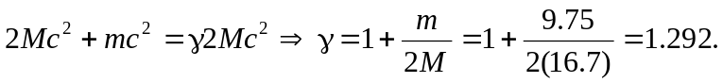
Note that since 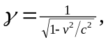we have that
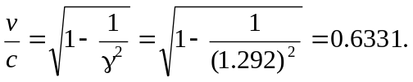
b) According to Eq. 37.36, the kinetic energy of each proton is
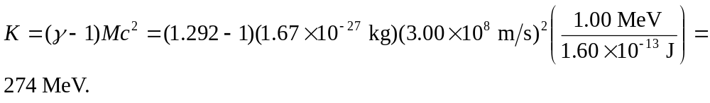 c) The rest energy of 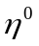is
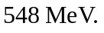

d) The kinetic energy lost by the protons is the energy that produces the 